TECHNOLOGY, MEDIA & TELECOM ABSTRACT
Water Managed Services Report 2018
Thomas Frashier, Smart Utility Infrastructure –Analyst–
April 2018
Actuals and ForecasT
Frequency, Time Period
- 5-year annual forecast (2017 - 2023)
- Base year (2016)
Measures
- Revenues (Services & Technologies)
Regions, Markets
- EMEA (Europe, Middle East & Africa)
- United States
- Canada
- Latin America
- Asia Pacific
- China
Competitive Market
- Qualitative analysis
- Business model exploration
TECHNOLOGIES And services covered
- Meter and Communications Hardware
- Communications Network
- Network as a Service (NaaS)
- Meter Data Management Software
- Software as a Service (SaaS)
- Billing Automation Platforms
- Industrial/Utility Platforms
BUSINESS MODELS COVERED
- Traditional
- Professional Services
- Managed Services
- Hardware as a Service
- Outcomes as a Service
- Shared Benefits
Over $13.5bn will be spent by water utilities on smart metering hardware before the end of 2023 – but what about the market beyond the meter? Professional services based around AMI, software platforms and data analytics are already on the rise and new business models could yet transform the market for vendors, especially if utilities start to seek an “Outcomes as a Service” model.
This first edition report from IHS Markit takes a future look at the evolving market place for technology-based services to the water utility, centred around the role of AMI and the all-important data. From applications such as the communications network, to meter data management software and analytics, the report will give market sizes and revenue projections for the next five years.
In the following chapters, primary research interviews with utilities, vendors and other technology companies are combined to create analysis on the impact of new business models. For example, “how much more revenue can be achieved through offering an ‘Outcomes as a Service’ solution through a shared savings cost model?”
Figure 4.2 – Managed Service Revenue (as a % of total service revenue)
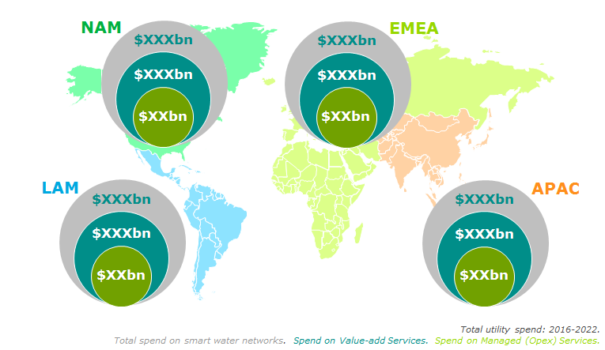

Key Issues Addressed  What are the technology services that utilities most need and willing to pay for right now and in the future?  Does any region offer a greater opportunity for vendors?  Which factors are key in determining the biggest ROIs for a utility?  How will the market size for SaaS compare to the market for NaaS? | How do the needs of different utilities (in terms of size and geography) differ?  Applicable To  Metering hardware manufacturers  Communications networking companies  Combined AMI vendors  Telecommunications  Industrial software platform companies

LEAD ANALYST
Thomas Frashier – Smart Utility Infrastructure
In the past two years, Thomas has been the lead analyst for the IHS Markit Electricity Meters Report 2017 as well as the Gas Meters Report in 2016 and 2017. Beyond the scope of just metering, Thomas also created a cross-team topical report over IoT in Utilities and contributed to a large custom study for a key client on the rise of managed services for the water utility sector.
Thomas has been with IHS Markit since July of 2016 and prior to that graduated from Southwestern University with a B.A. in Business. Thomas is based in the company's Austin, Texas office and can be reached at: Thomas.Frashier@IHSMarkit.com.

About IHS Technology SMART UTILITY INFRASTRUCTURE Coverage
Our coverage of the smart utility infrastructure industry has spanned over 15 years, with a core focus on the growth of smart metering technology for water, gas, electricity and heat. Through our annual research and datasets, we have a long established and robust methodology to accurately size the market and forecast the future. Additional, large-scale custom projects for some of the biggest industry players have also seen us expand our knowledge and reach across the industry; from sizing the transmission and distribution grid hardware market, to exploring the future business models for managed services to water utilities. Our global research team is now launching a new syndicated research service to cover the transmission and distribution markets for electricity hardware.
Table of Contents  Executive Summary  Chapter 1 Introduction and definitions  1.0 Introduction  1.1 Contents  1.2 Definitions  1.3 Scope  1.4 Methodology  1.5 Exchange rates  Chapter 2 Drivers and Inhibitors  2.0 Introduction  2.1 Market History  2.2 View from the utility  2.3 Overview of key factors  2.3.1 Legislation/Regulation  2.3.2 Market Factors  2.3.3 Utility Factors  Chapter 3 Market Forecasts for Managed Services  3.0 Introduction  3.0.1 Assumptions  3.0.2 Model overview  3.0.3 Benchmark service costs  3.1 Global Market Sizing  3.2 Regional Market Sizing  3.2.1 United States  3.2.2 Canada  3.2.3 Europe  3.2.4 Middle East  3.2.5 Africa  3.2.6 Latin America  3.2.7 Asia Pacific  3.2.8 China  Chapter 4 Future Business Models  4.0 Introduction  4.1 “as a Service”  4.2 Shared Benefits  4.3 Third party usage | Chapter 5 Future uses for AMI data and communications  5.0 Introduction  5.1 View from the utility  5.2 Current solution  5.3 Future solutions  5.4 Regional analysis  Appendix 1 – List of tables  Appendix 2 – List of figures  Appendix 3 – Geographic Segmentation  Note – final TOC may vary.

